Writing practice
Have a look at this email and answer the questions.
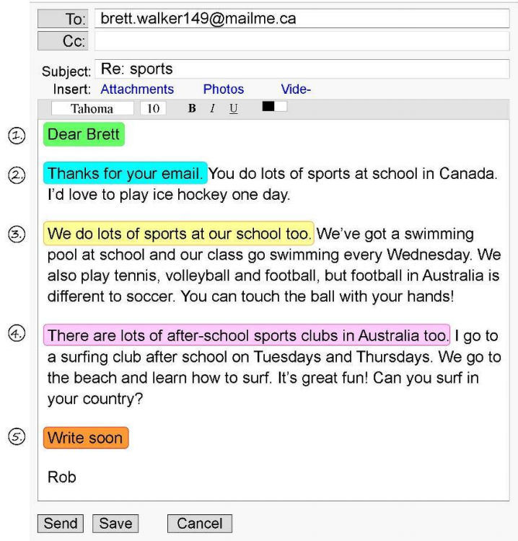
How to write a letter:
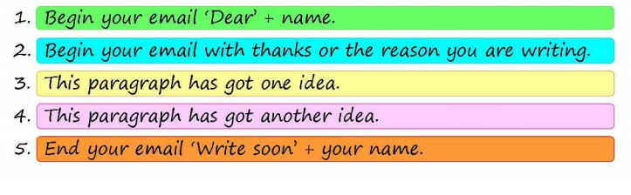
Questions:
1. Check your understanding: true or false
1. Rob is from Canada. True False
2. Rob wants to try ice hockey. True False
3. There is a swimming pool at Rob's school. True False
4. Rob goes swimming on Tuesday and Thursday afternoons. True False
5. Rob thinks football in Australia and soccer are the same. True False
6. Rob often goes to the beach. True False
2. Reply to Rob’s email.

Tell him about sports in your school. Think about these questions:
- What sports in Rob’s school would you like to try?
- What sports do you do at your school?
- What after school sports clubs do you go to?

Write a letter of 100 to 150 words. Think about the 5 elements that should be in a letter and are shown above.
Write your letter here:

